(Approx. 615 words)

Recover Your Wi-Fi Password
David Kretchmar, Hardware Technician
Sun City Summerlin Computer Club
https://www.scscc.club
dkretch (at) gmail.com

Computer users often seek technical support when they cannot access the Internet via their home wireless system.

First, the technician will usually walk the user through the reset procedure for the router or router/modem (turn them off and on). If that does not fix the problem and it is determined the modem is receiving a good signal, the subsequent conversation often goes something like this:

Technician: What is your password for your router?

User: I don’t have a password.

Technician: If your router is not secured (i.e., password protected), you should be able to connect.

User: I don’t have a password. I click the Google (or other browser) icon and get online.

At this point, the Technician explains to the User that the password is stored on the User’s computer and that a few steps are required to access that password. The technician might guide the user through the process of recovering the password using the following procedure:

If the computer connects to the Wi-Fi, it automatically.

Microsoft has buried the Wi-Fi password on a computer more deeply with the latest version of Windows 10 and 11 than with prior versions. It is the same procedure for both 10 and 11. You can still find your Wi-Fi password using the following steps (note … where I use the term “click,” I mean a single click on the left mouse button or a single tap on a touchscreen.):

Find your way to the “Wireless Properties.”

Open your Control Panel (Type “Control Panel” into the search box to the right of the Windows button on your Taskbar and Enter). Click on Network and Internet. Click on Network and Sharing Center, then click on the name of your network, which appears in blue. In the Wi-Fi window that opens, click on Wireless Properties. In the new window that opens, click on the Security tab, then check the box on Show Characters.

If you only own a smartphone/tablet or have a PC that has not stored the Wi-Fi password

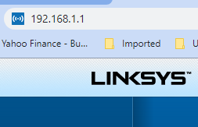
Log in to your router as an administrator. You can access your router by entering its IP address into your browser, such as Google Chrome or Microsoft Edge. You can research the default IP address of your router by Googling “IP address [brand name of your router]. Every router I’ve dealt with had an address of “192.168.X.X”. The most common value for X is the number 1 (for both Xs). If that does not work, try substituting the numbers 0 or 2 for one or both of the Xs. After you log in, you should be able to find the Wi-Fi settings on the Administrative pages of your router. There, you can look up your password.

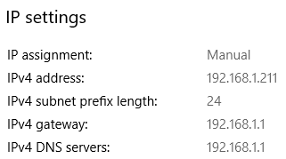
Ed. Note. On Windows 10/11, you don’t have to guess. You can find the internal IP address of your network router by going to Settings > Network and Internet > Status and, under the name of your Wi-Fi (or Ethernet) connection, clicking Properties. A screen will display; near the bottom are the IP settings. The IPv4 gateway IP address is the internal address of your router.

If you are like many people

The Wi-Fi password is often written on a sticker on the back of your router. This is how I usually set up home routers, and it might be a good thing to do after you have recovered your Wi-Fi password.

This is a simple but effective strategy since it is easy to find.

A burglar would have to break into your home to steal your password, and they probably would focus on more tangible items.

